KELCO INDUSTRIES
ORDER TO CASH
PROCESS FLOW DOCUMENT

Login To Role: Sales Manager
Customer Creation

Navigation: List -> Relationships -> Customers -> New

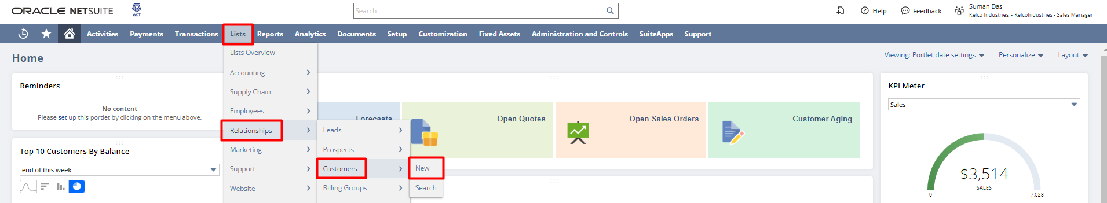

In the Customer record, enter the Company Name, Email, Address, status, and other necessary details. Click on the pencil icon to enter/edit or add multiple Addresses. If the address is a default billing/shipping or both, check the checkboxes. Click on Save.

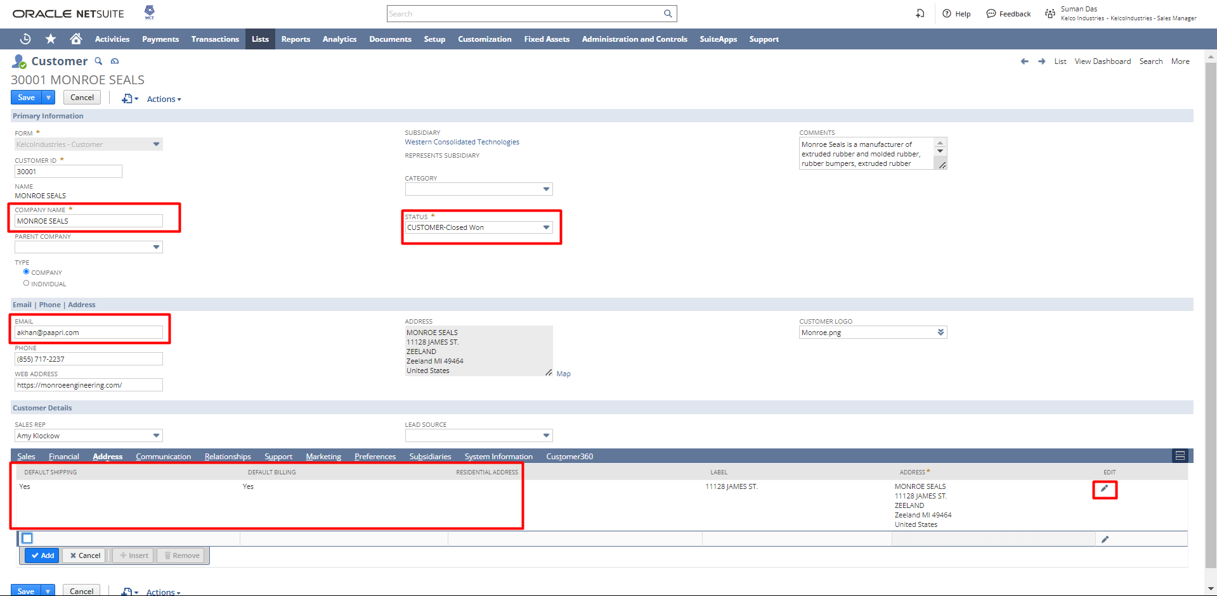

Sales Order Creation from Quote
Navigation: Transactions -> Sales -> Prepare Quotes -> List.

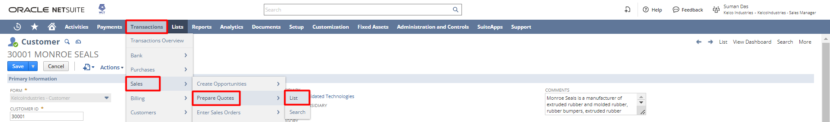

A list of quotes will open and click on the View hyperlink beside the Quote that you want to convert to a sales order.

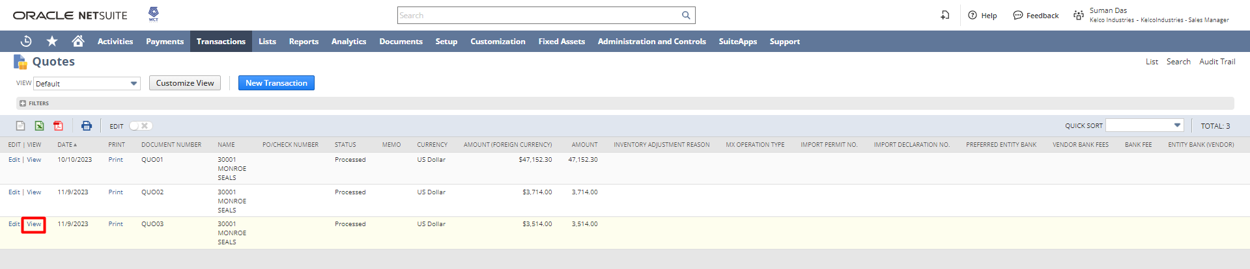

From the view mode of a Quote, click on the Sales Order button and it will open the sales order form with the Quote information.

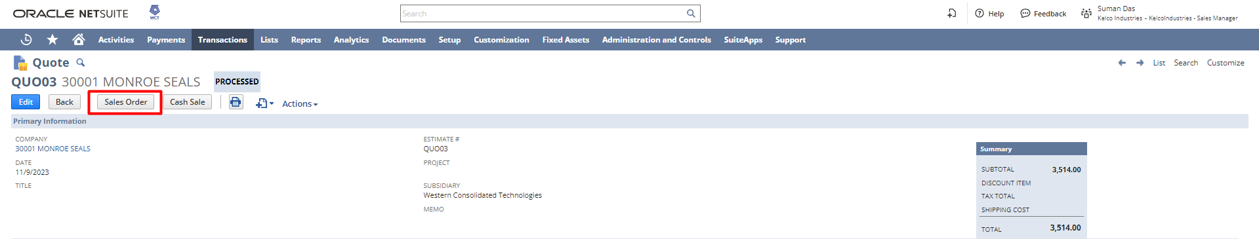

If required, the user can modify the field value and save the record or can directly save the record. 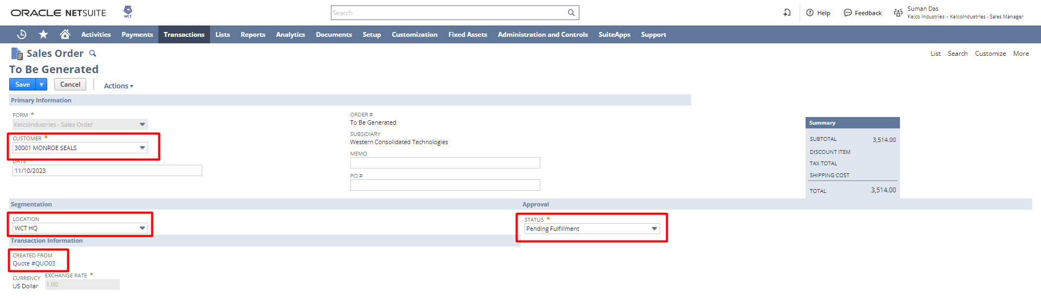

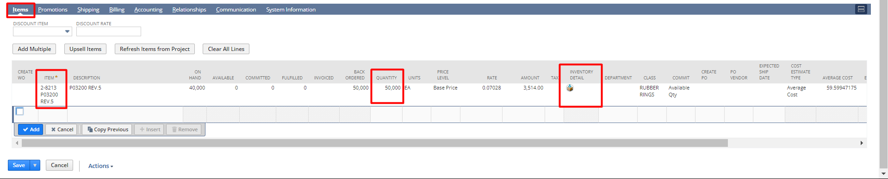

On clicking the Inventory Detail, the below pop-up will open
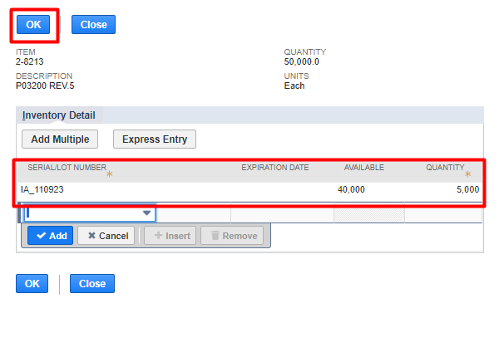

Note: For demo purposes, we have created a Sales Order with an Assembly item. However, you can select an inventory item too for testing purposes, and in our further session.

After saving the sales order check the details and if the details entered are correct then click the Approve button.

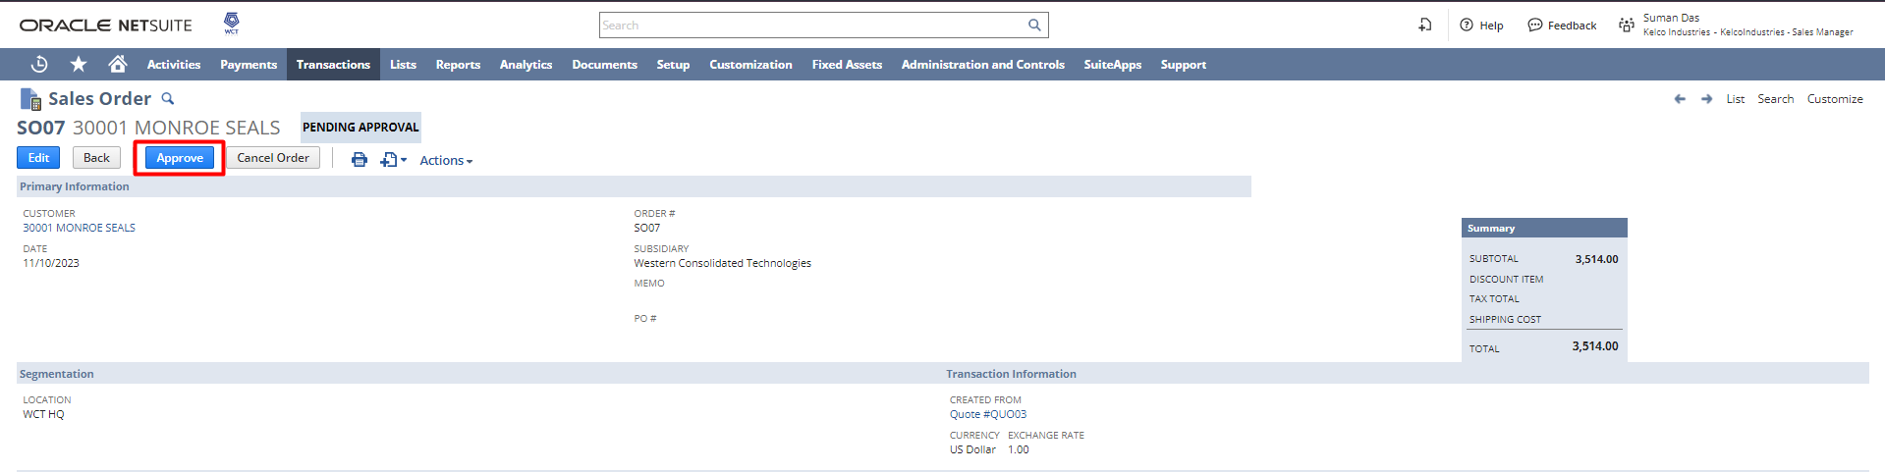

After creating the Sales Order, the user can print the Sales Order transaction PDF and the Picking Ticket from the sales order.
Open the sales order, hover on the print icon, and click on Print to print the sales order as shown below:

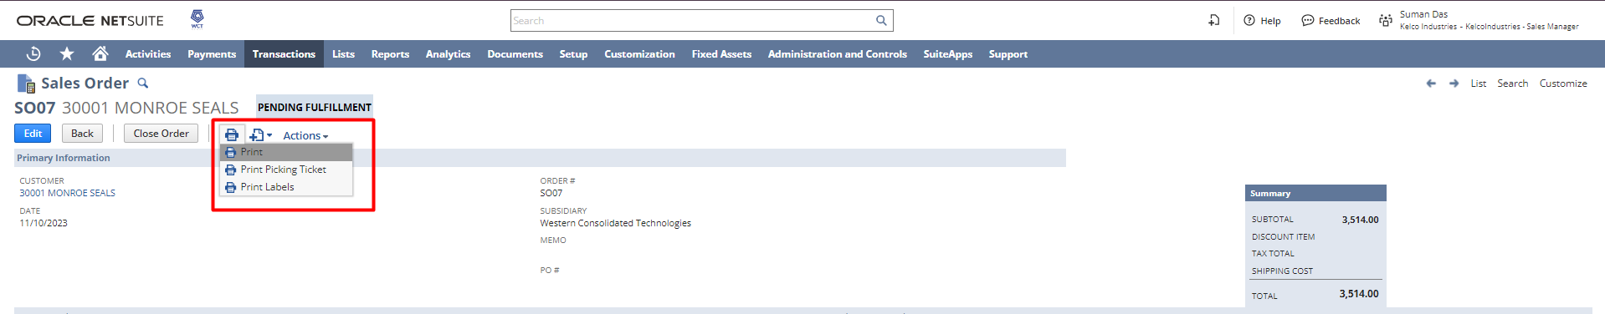

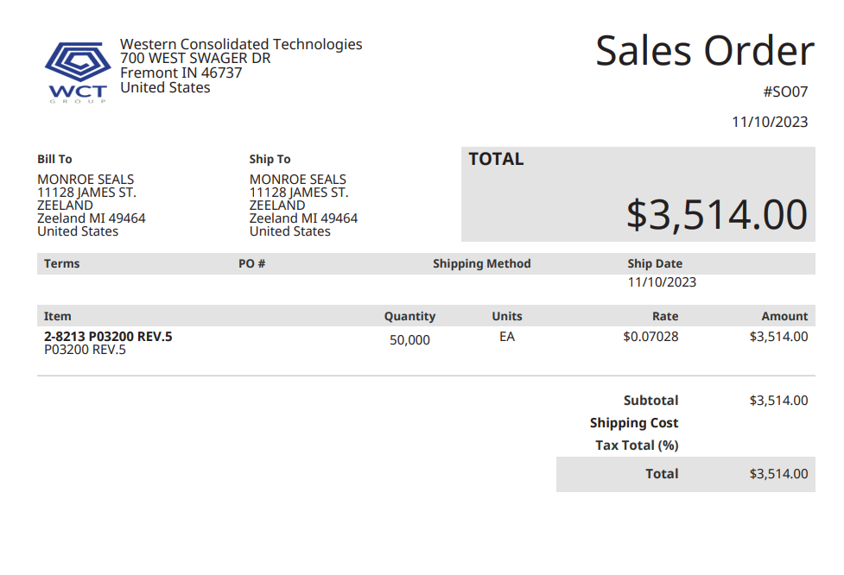

Similarly, Picking Ticket can also be printed from the Sales order by hovering on the print icon, and clicking on Print to print the sales order as shown below:

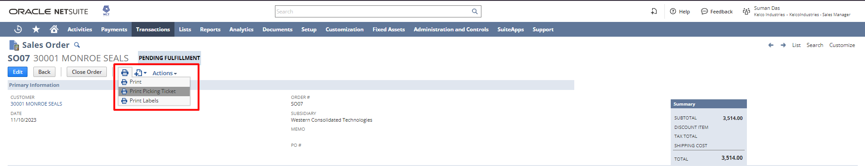
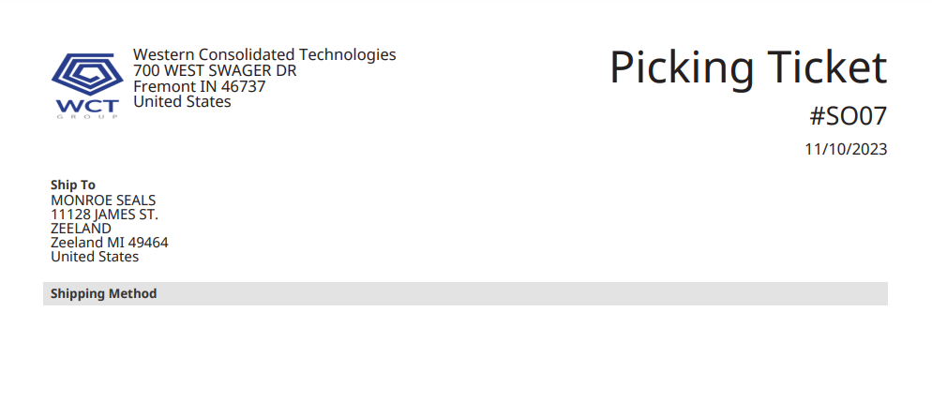

Login To Role: Warehouse Manager

Item Fulfillment

Click on the Orders to Fulfill hyperlink from the Warehouse Manager Dashboard Reminders section.
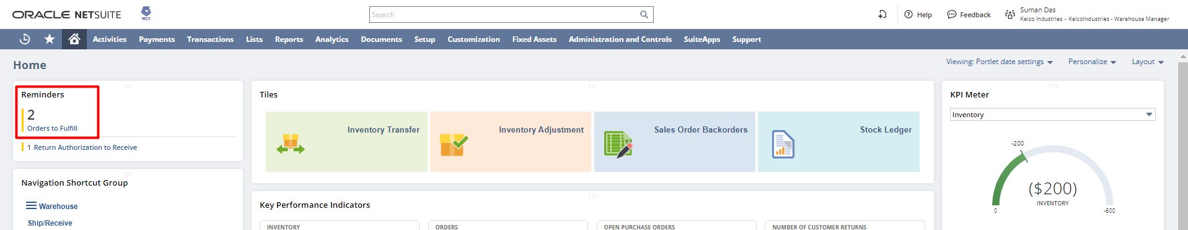

You can directly check the checkbox and click on Submit to create multiple Fulfillments at a go.

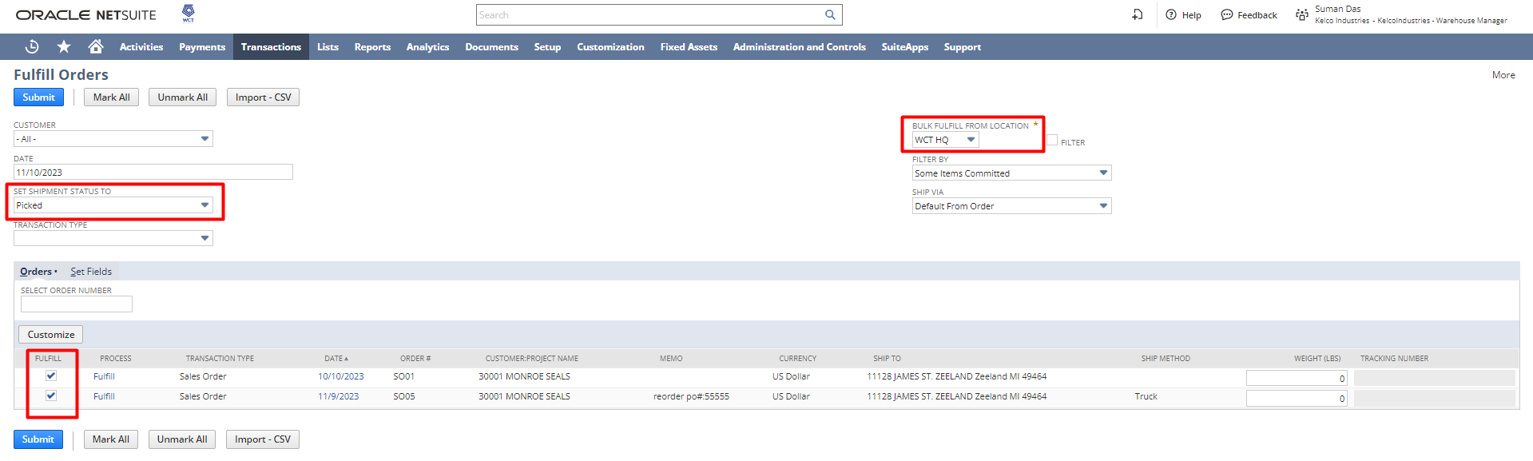

Or to view/edit the information click on the Fulfill hyperlink which will redirect to the fulfillment page check the details and click Save.

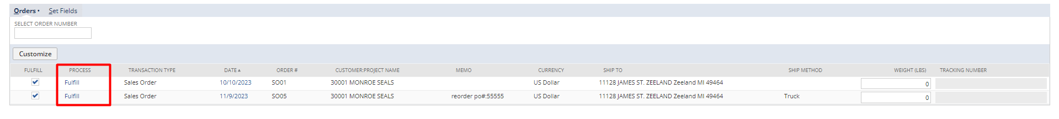

To print the Packing Slip hover on the print icon and click on the Print button.

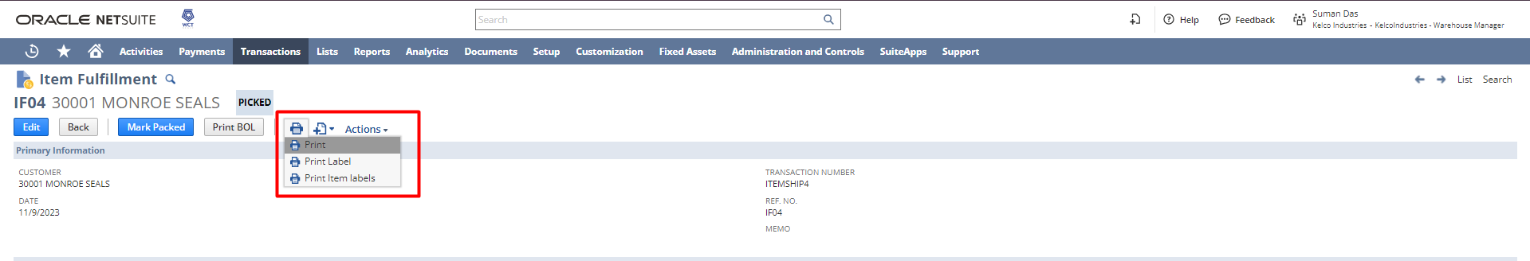

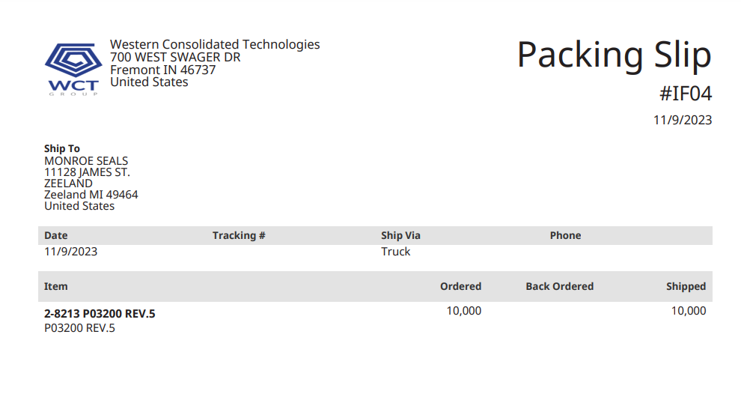

From the fulfillment page click on the “Mark Packed” button to convert the fulfillment status to Packed.
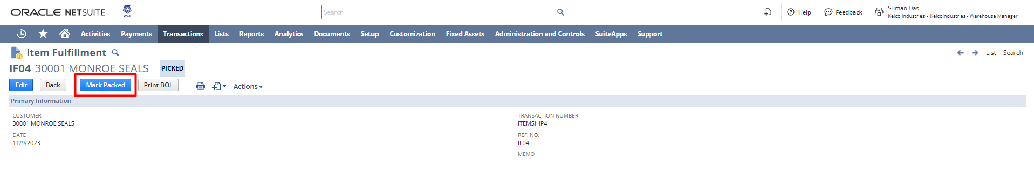

Click on the “Mark Shipped” button to convert the fulfillment status to Shipped.
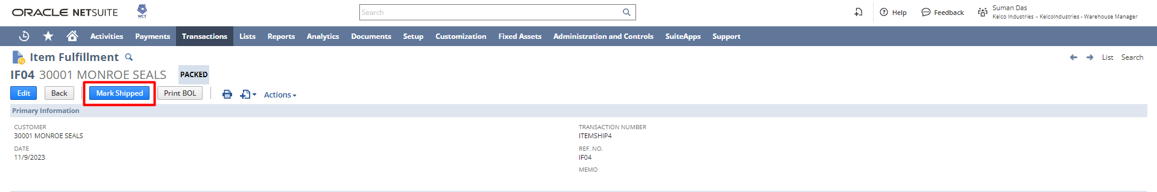

After marking the fulfillment as Shipped, the final record will look like the below:
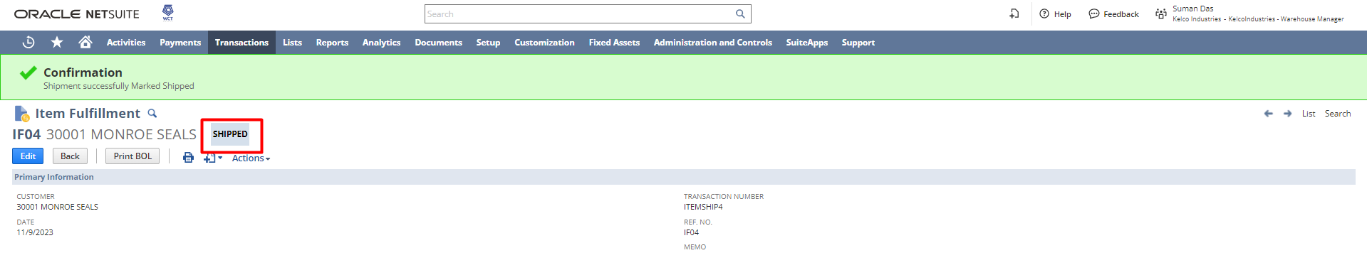

Login To Role: A/R Analyst

Invoice Creation
From the A/R Analyst dashboard click on the Sales Order to Invoice under reminders.
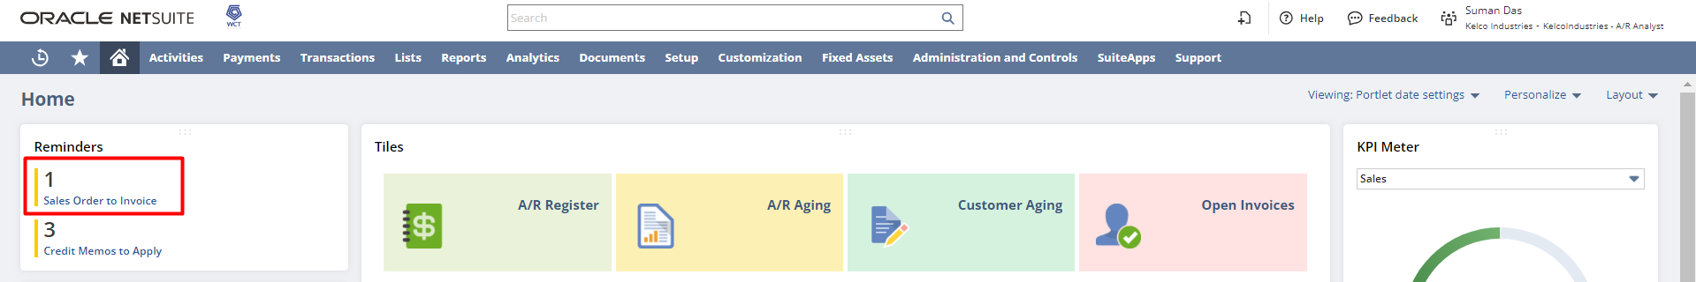

A list of Sales Orders will open, you can check the checkboxes and click on submit to create multiple invoices at a go.
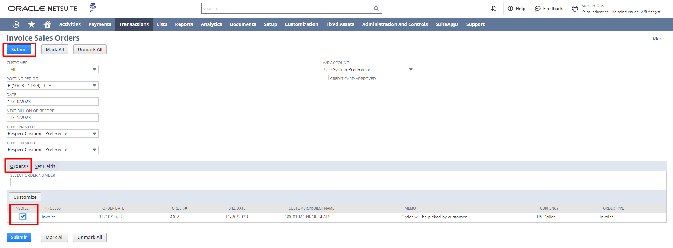

OR,

You can click on the Invoice hyperlink beside the sales order for which you want to view the details and save the record to create the Invoice.
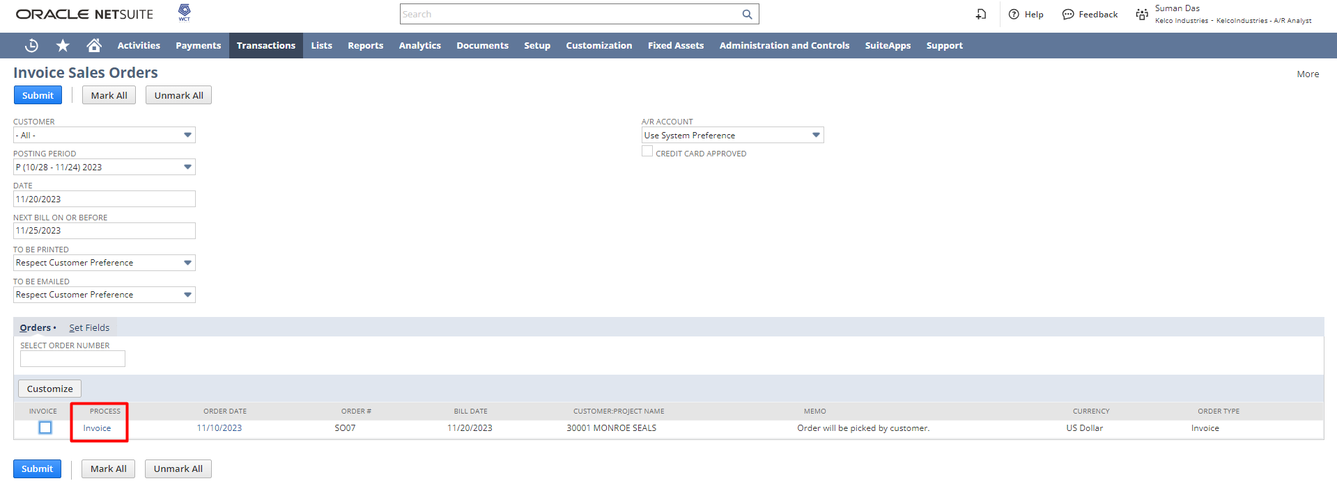
All necessary details will be auto populated from the sales order record. After that click on the Submit button.
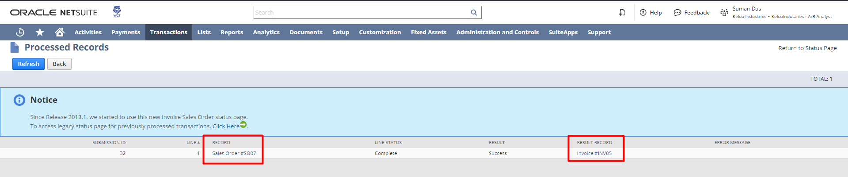

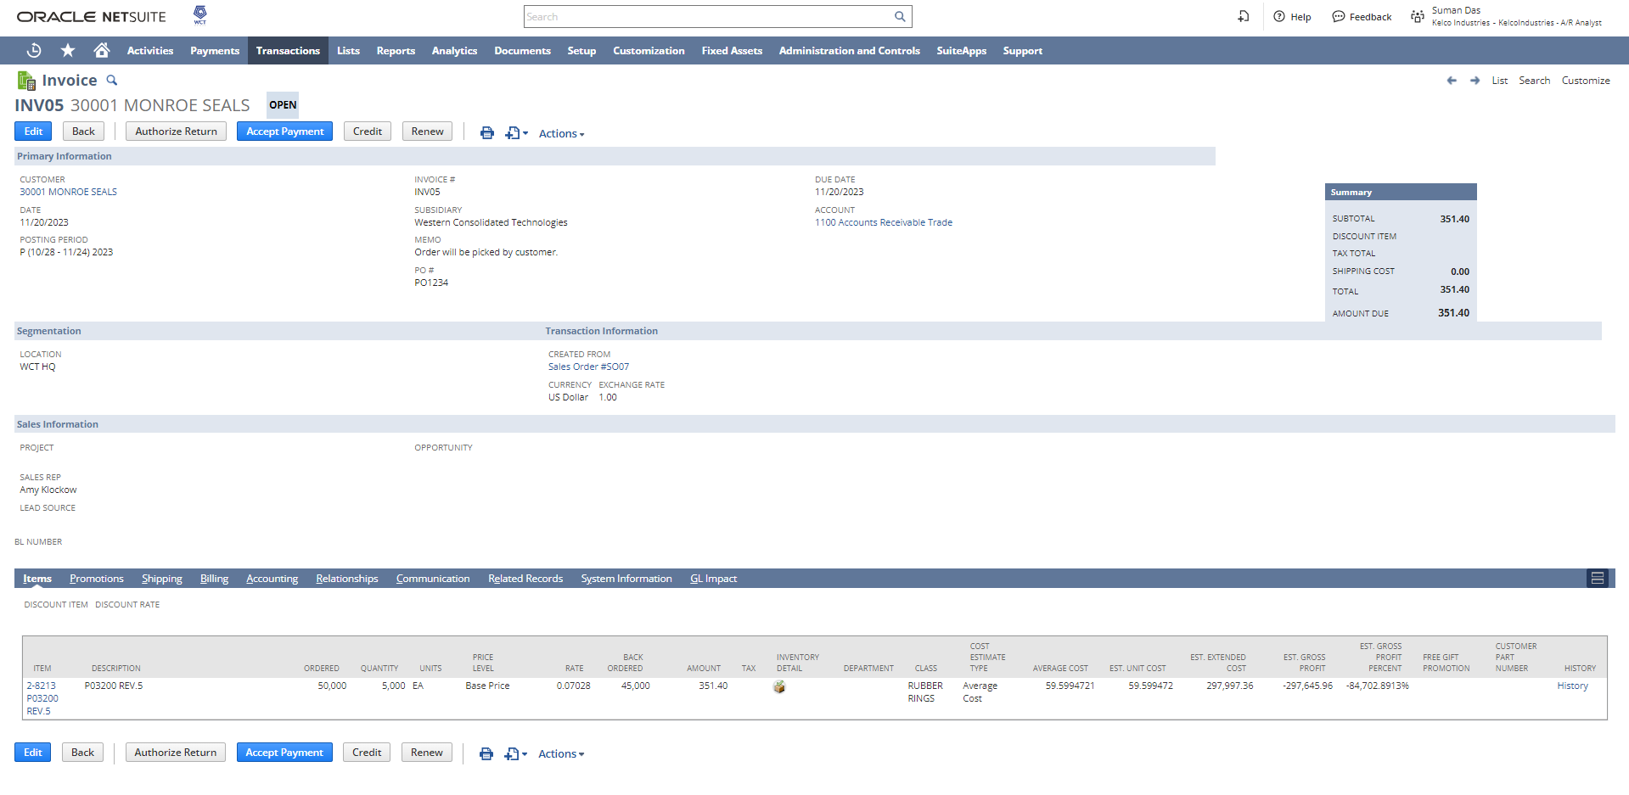

Under the Shipping subtab, the shipping information will be auto populated from the Sales order.
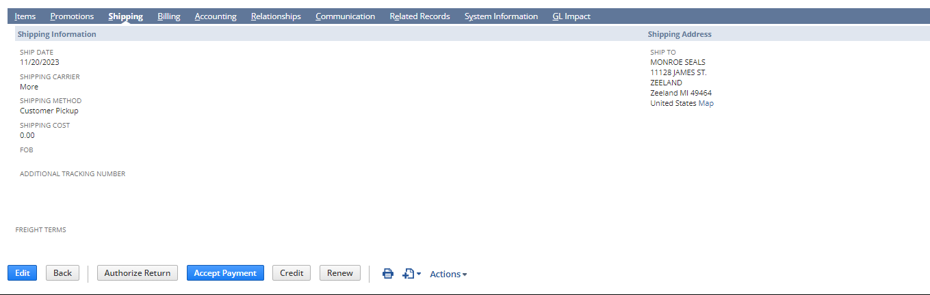

Under the Billing tab, the Billing information will be auto populated from the Sales order.
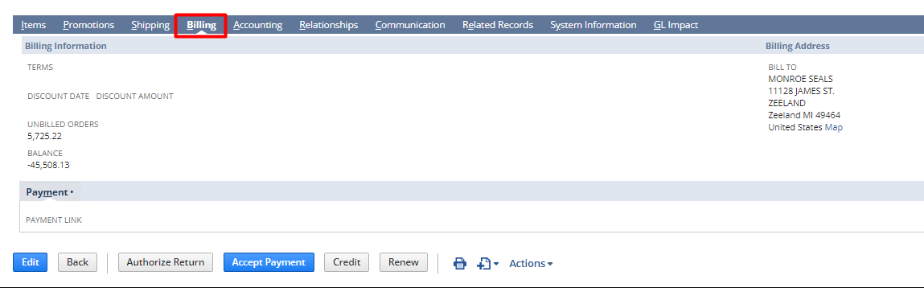

Under the communication tab, the user can add a mail address to send automatic mail with the attached PDF.
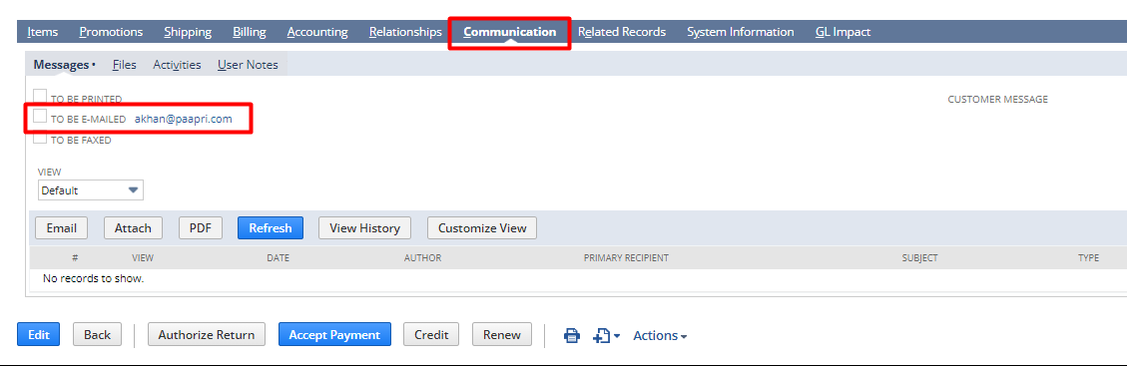
[NOTE: Check the To BE E-MAILED checkbox after putting the email address]

Accept Payment
Navigate to the saved invoice and click on the Accept Payment button.
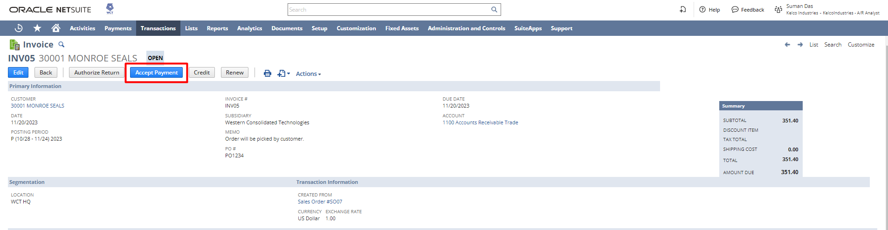

The payment page will open verify the details and click on Save.
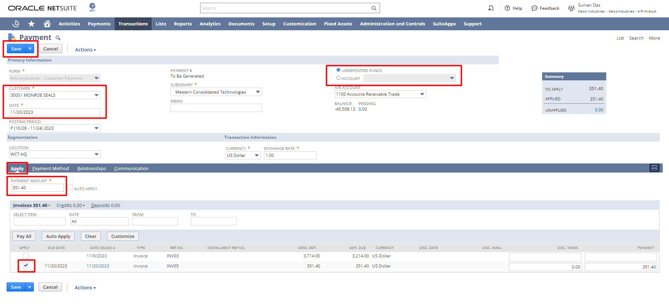

Login To Role: Sales Manager
Return Authorizations

Navigate to Transactions -> Sales -> Enter Sales Orders -> List to open the list of sales orders.
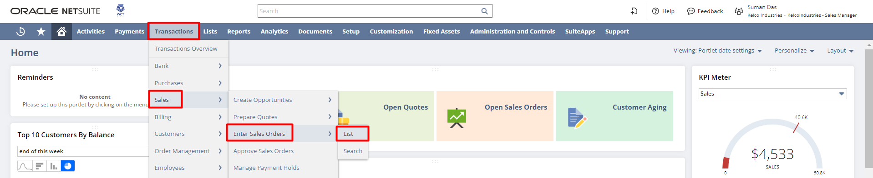

A list of sales orders will open click on the View hyperlink beside the sales order for which you want to create the Authorized return.
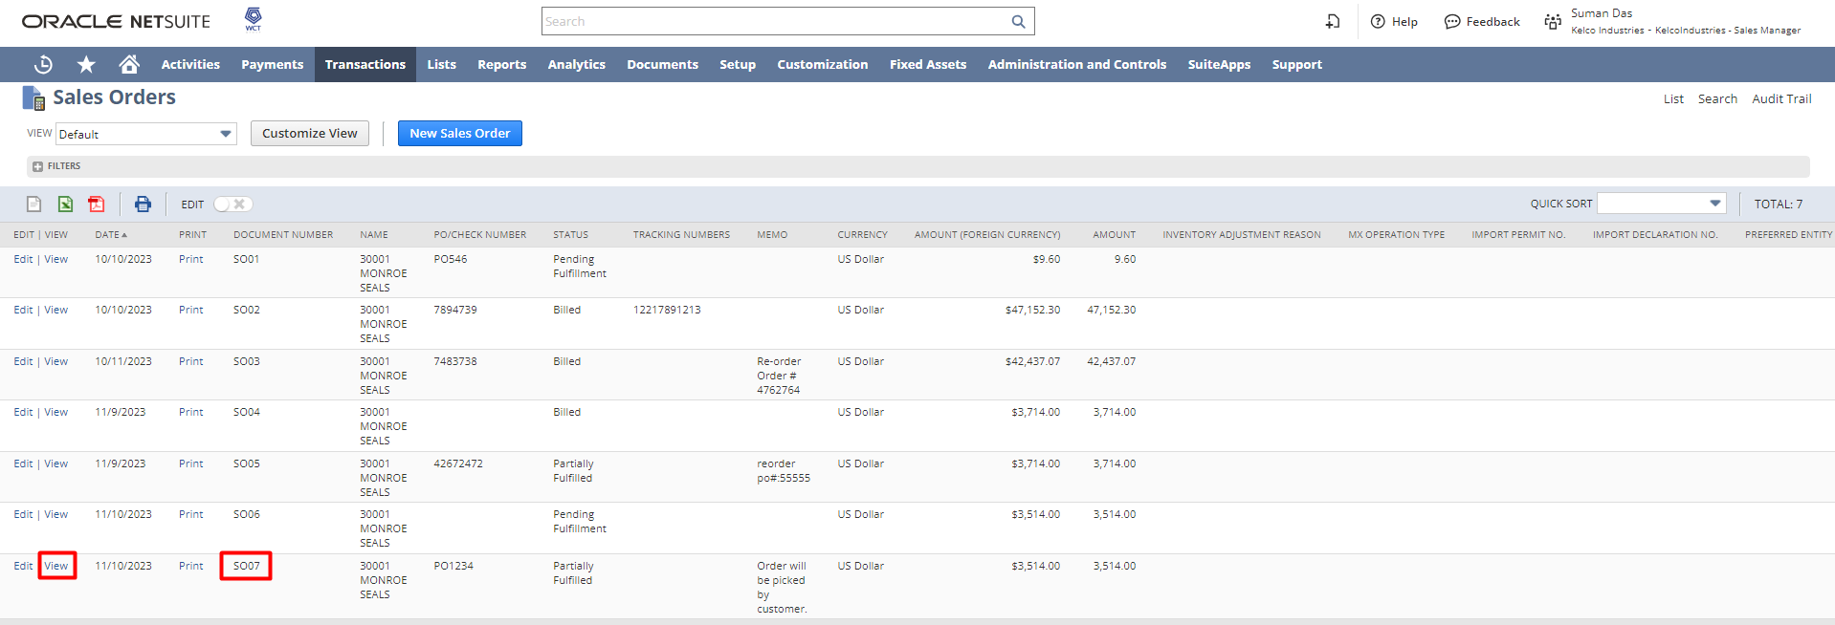

From the Sales order page click on the Authorized Return button.
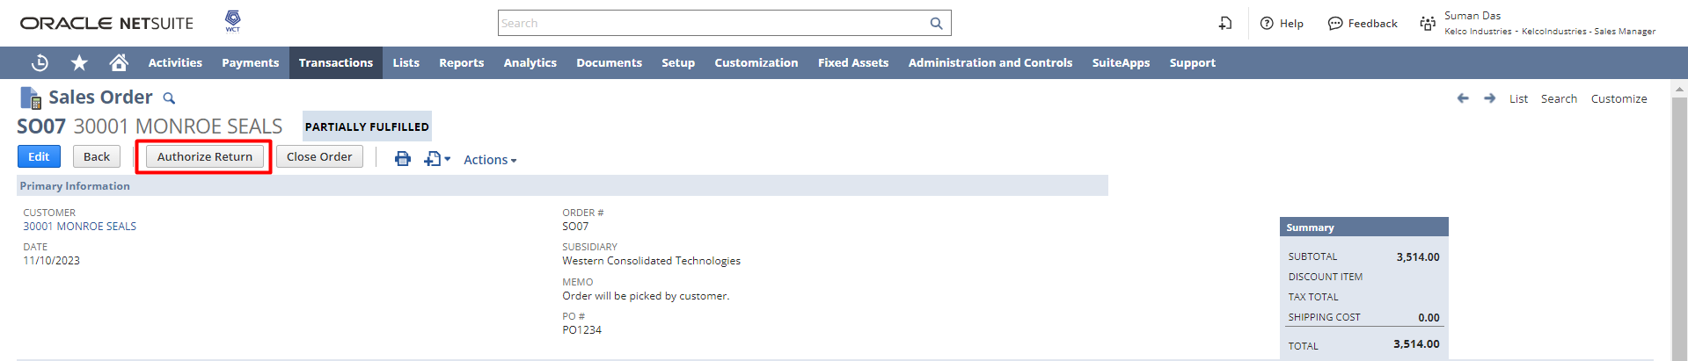

The Return Authorization page will open. Change the status to Pending Receipt and make the necessary changes if required, then click on Save.

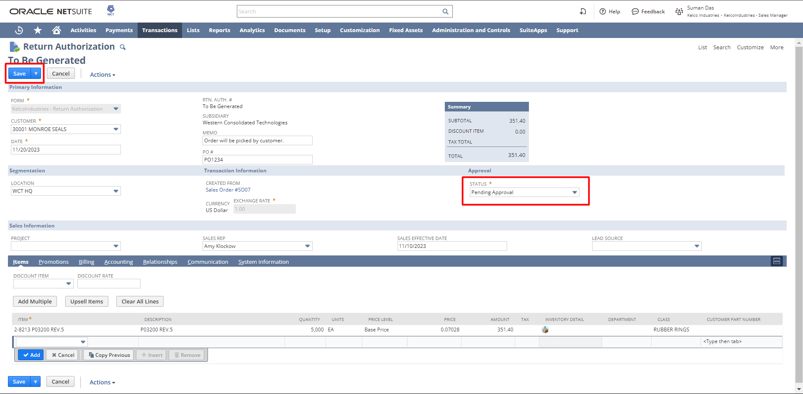

The user can click on the print icon on the view mode of the Return Authorization to print the Return Authorization.

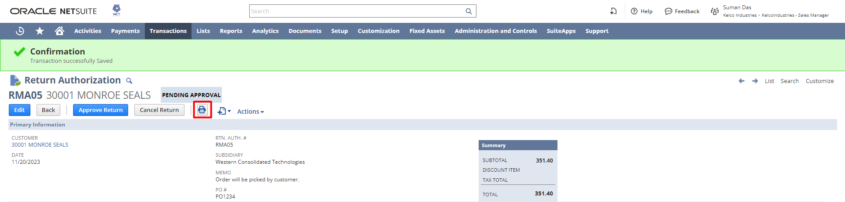

A new tab will open with the Return Authorization PDF.

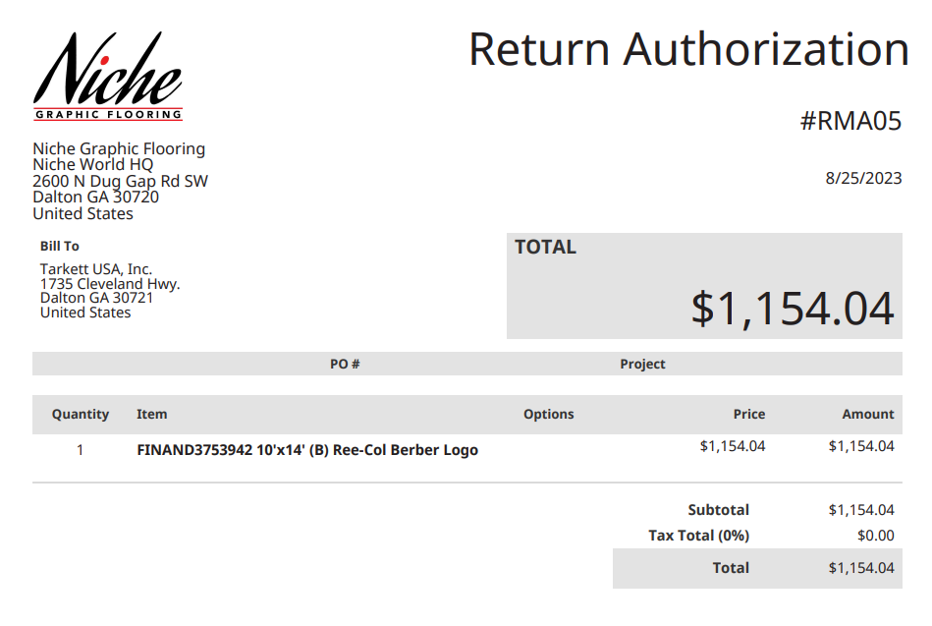

Note: You can create the Authorized Return from the Invoice record also. To create you need to open the related Invoice in View mode and click on the Authorized Return button.

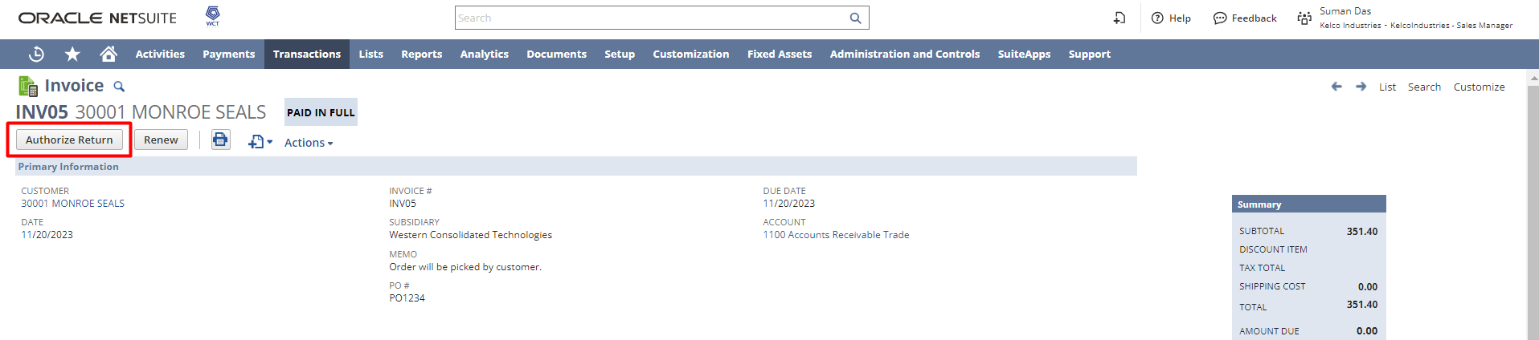

Login To Role: Warehouse Manager

Item Receipt
Navigate to Reminders -> Return Authorization to Receive
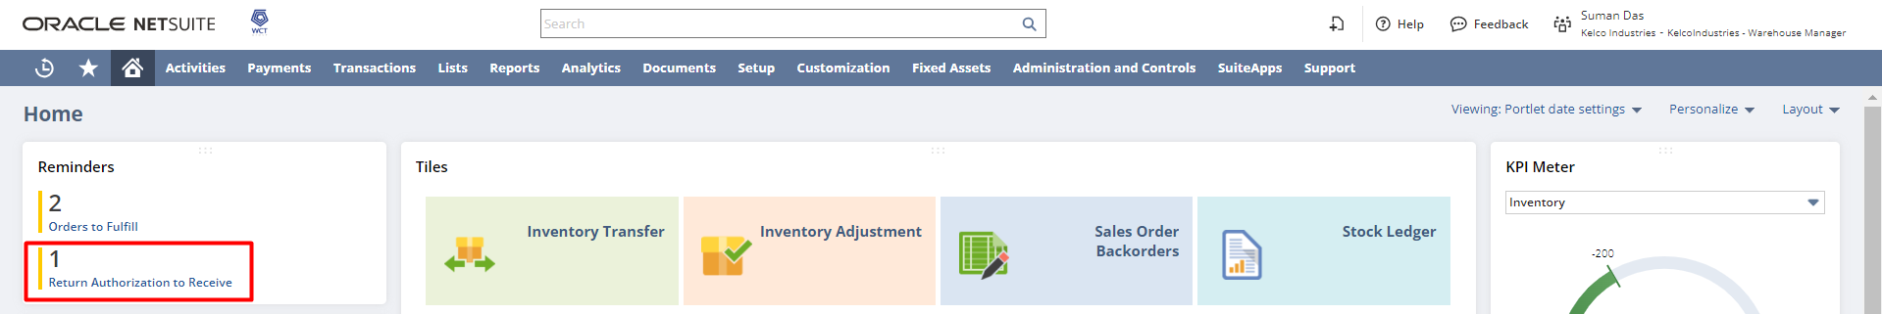
The list of Return authorizations will open. You can check the checkboxes to receive multiple returns at a go and click on Submit.
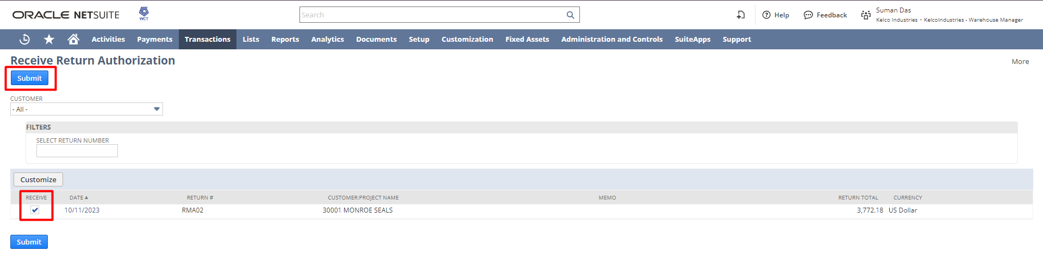
OR,
The User can click on the Date hyperlink to view a specific return authorization.
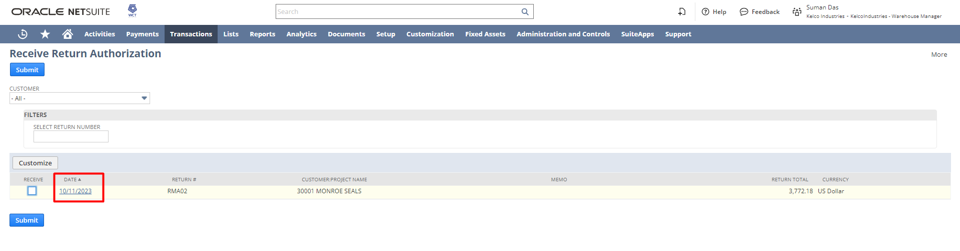

The Return Authorization page will open. The user needs to click on the Receive button in the view mode of Return Authorization.
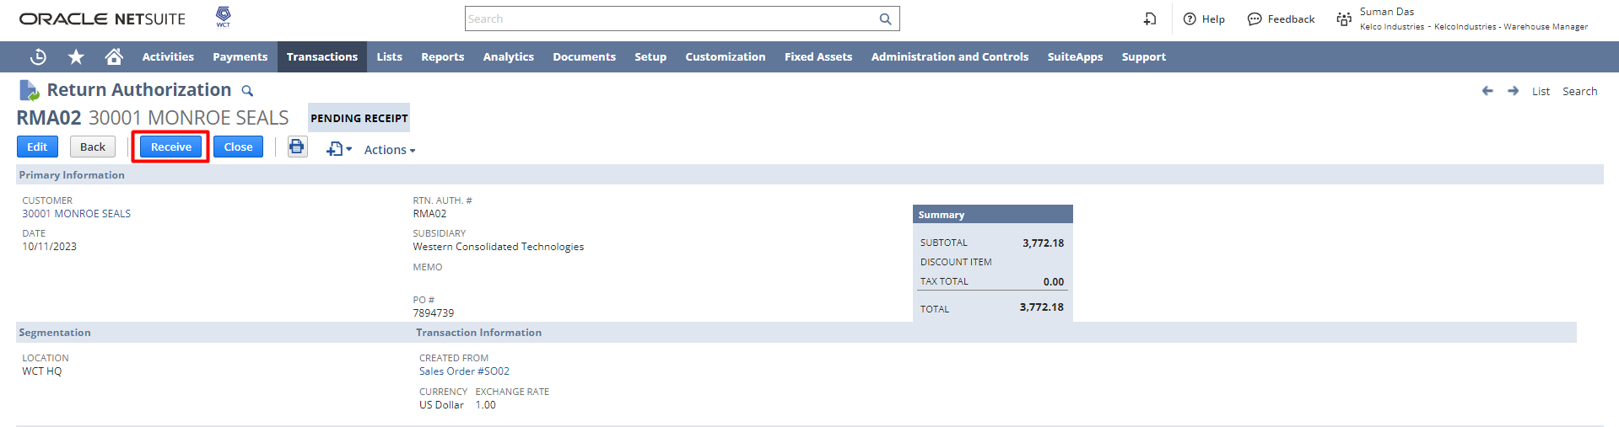
After that, the Item Receipt page will open with the details of the Authorized Return, Verify the details and click on Save to save the Item Receipt record.

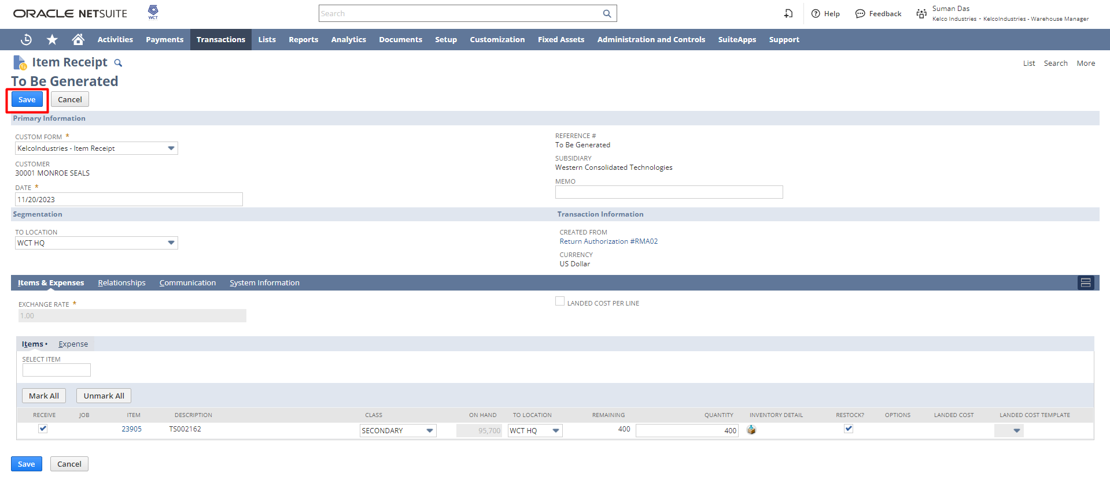

Login To Role: A/R Analyst

Refund Return Authorization
Navigate to Reminders -> Return Authorization to Refund.
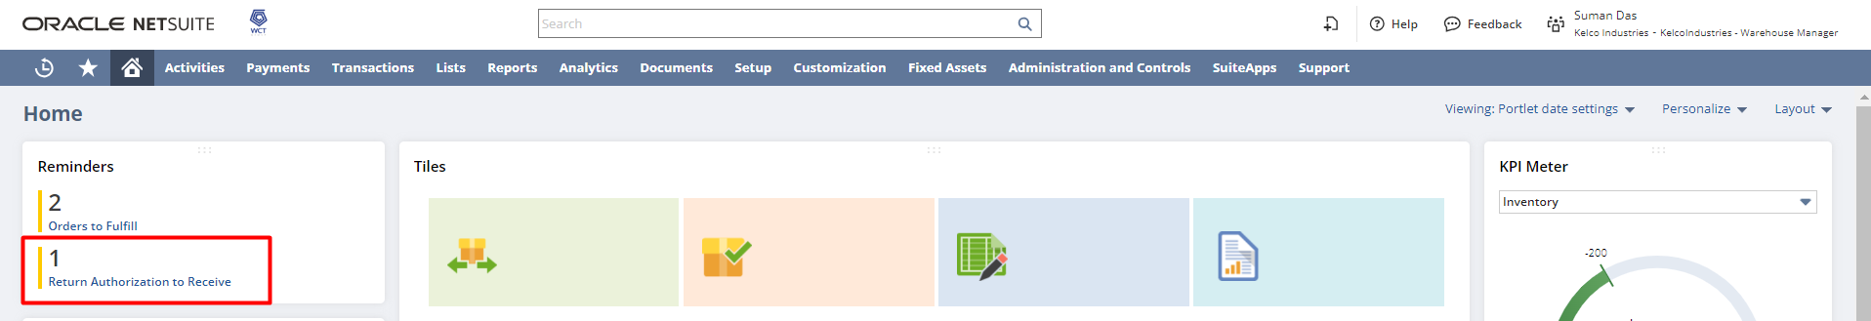

The refund Return Authorization page will open. The user needs to check the checkboxes and click on submit to create multiple refunds at a go.
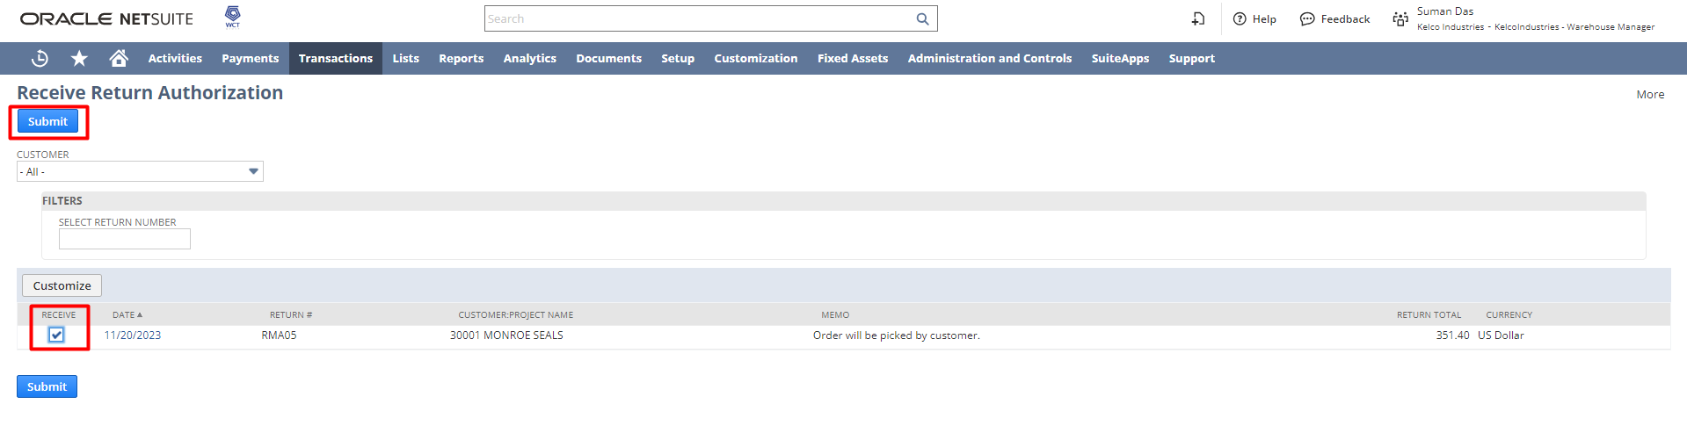
OR,
You can click on the Date hyperlink to create the refund from the Return Authorization page.
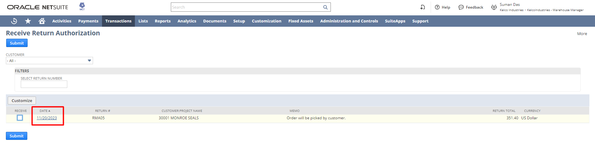
After that, the return authorization page will open in view mode. You need to click on the Refund button.
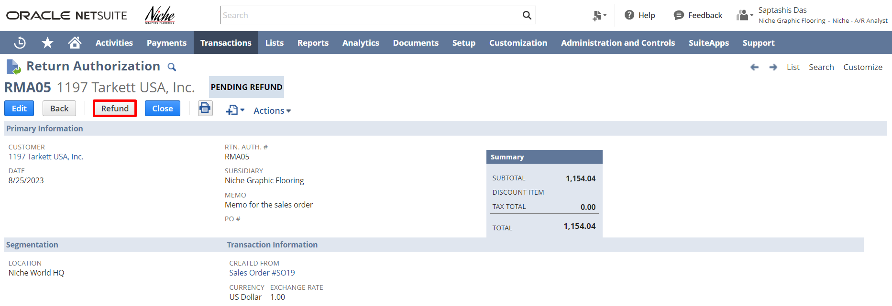
The Credit Memo form will open with the prepopulated information from Return Authorization.

Credit Memo
The user needs to review (the user can modify the prepopulated values as per their need) and click on Save.
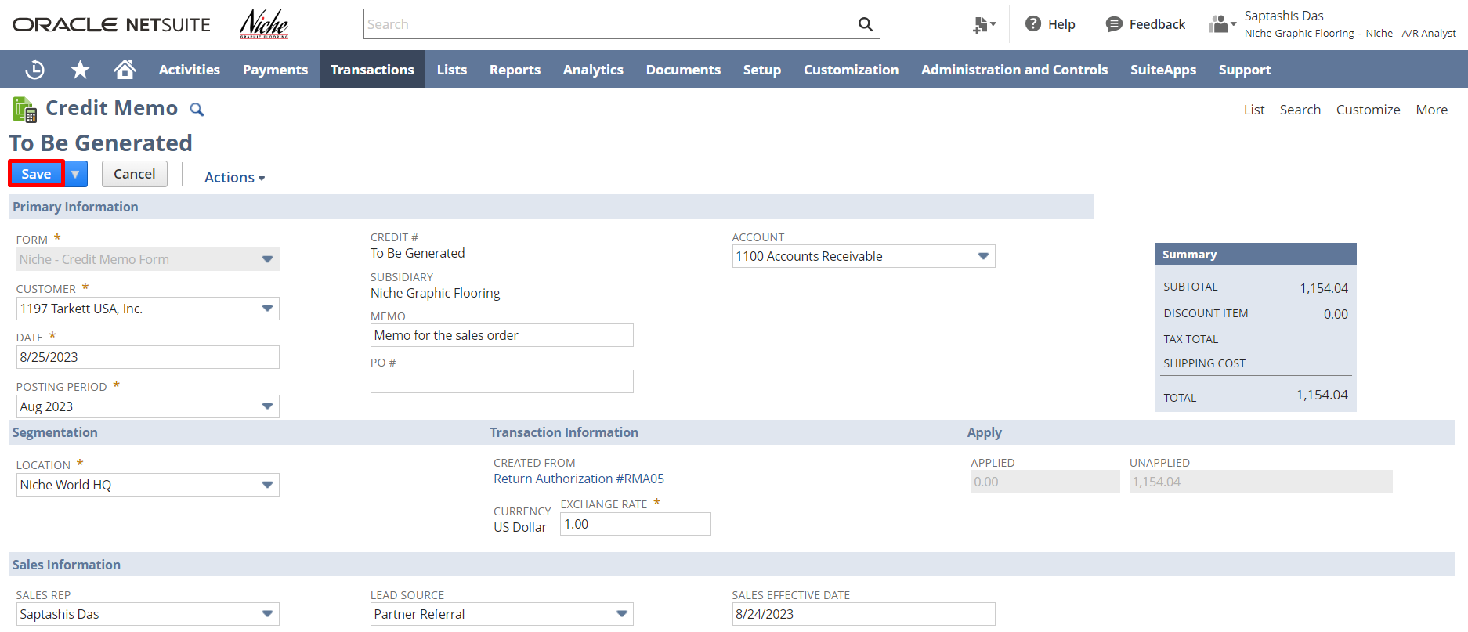
l 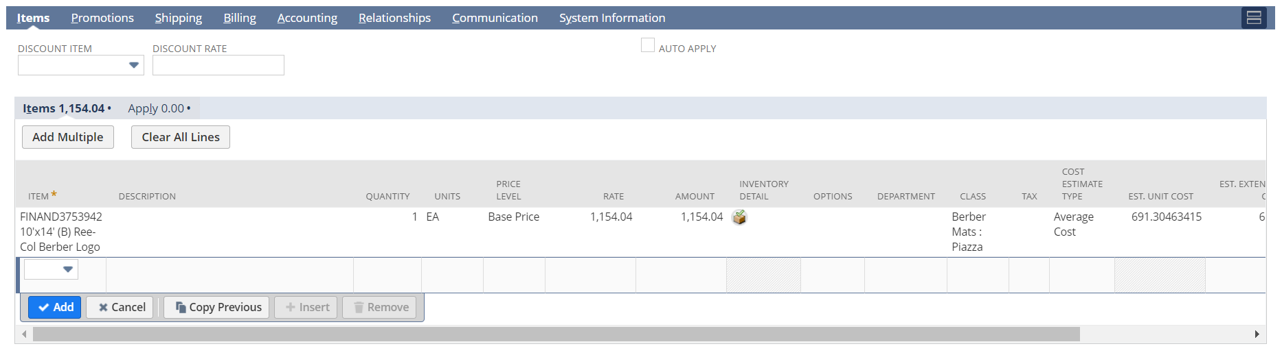

After that, to print the Credit Memo, hover on the print icon on the view mode of the credit memo and click on Print.
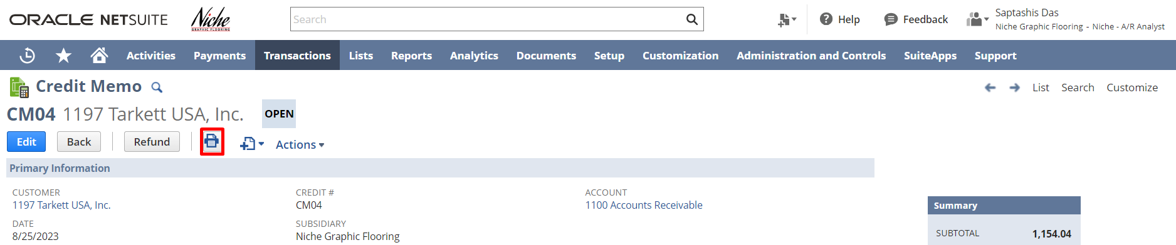

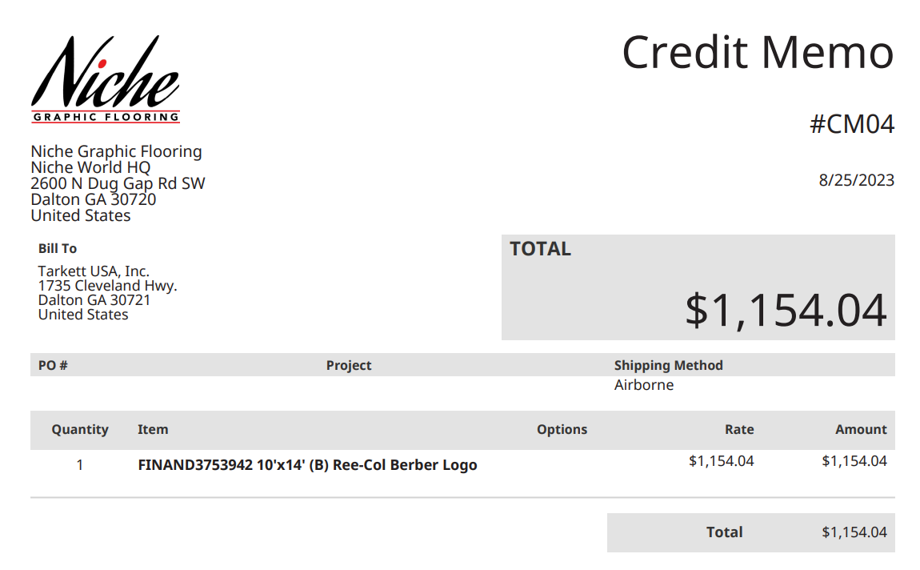

If needed, the user can click on the Refund button from the credit memo record to generate a customer refund.
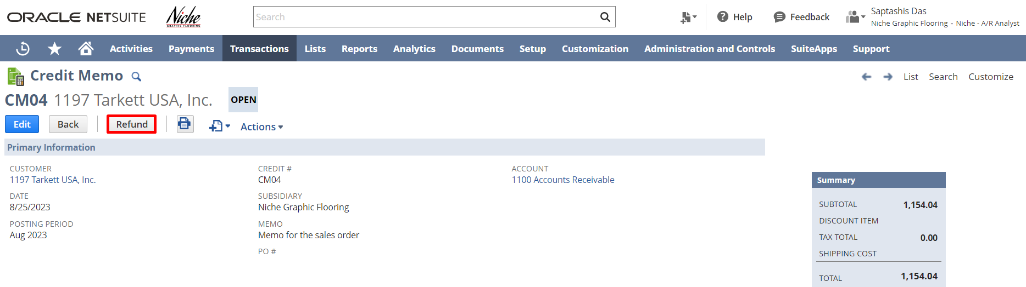

The Customer Refund form will open with prepopulated information from the credit memo. Click on Save.
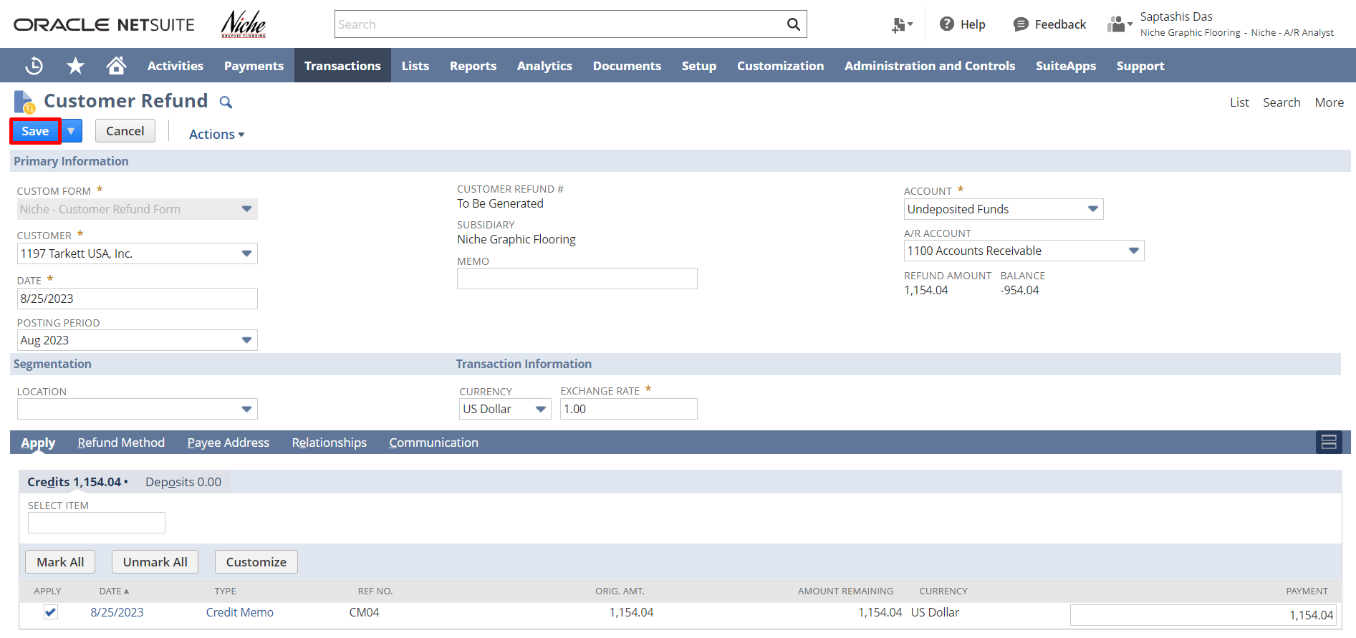

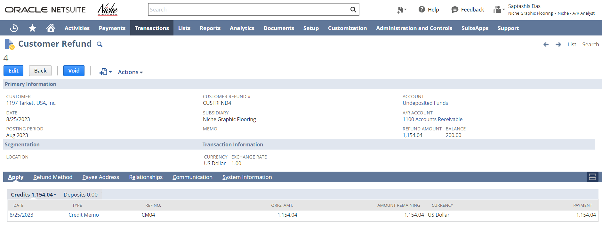

Please utilize the below feedback link for the Order to Cash module:
https://form.typeform.com/to/woCmtXub

Signature:

Date:

Disclaimer:
Upon signing off on the process flow document, you are confirming that the process has been set up per the SOW within NetSuite per your business's needs. Any changes or modifications requested after sign-off will need to be a "change request" at an additional fee.

*** PLEASE ensure that you have logged into NetSuite and tested the process prior to signing off on the setup. Paapri requires sign-off on this document prior to moving forward with any additional design meetings.

